**Ideation Phase**

**Define the Problem statements**

|  |  |
| --- | --- |
| Date | 27-06-2025 |
| Team ID | LTVIP2025TMID46688 |
| Project Name | DocSpot |
| Maximum Marks | 4 Marks |

**Define the Problem Statement:**

**Customer Problem Statement Template:**

Create a problem statement to understand your customer's point of view. The Customer Problem Statement template helps you focus on what matters to create experiences people will love.

A well-articulated customer problem statement allows you and your team to find the ideal solution for the challenges your customers face. Throughout the process, you’ll also be able to empathize with your customers, which helps you better understand how they perceive your product or service.

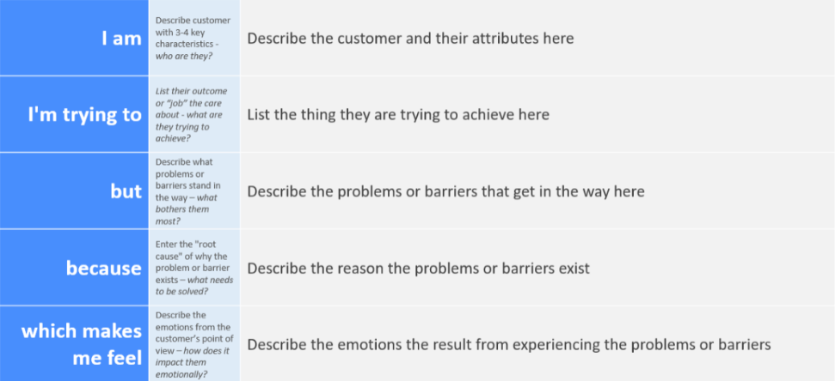

**Example:**

In today’s fast-paced world, patients face multiple challenges when trying to book medical appointments. Most traditional hospital systems rely on manual appointment booking, which causes long waiting times, lack of transparency, and inconvenience — especially for people in remote areas or with emergency needs.

Additionally, there is no centralized digital platform to:

* Easily find verified doctors,
* View availability in real-time,
* Book appointments instantly,
* And manage follow-ups efficiently.

This lack of a structured digital solution leads to:

* Wasted time for patients,
* Inefficiency for doctors in managing their schedules,
* And a poor overall experience for both parties.

**Problem Statement**

“To design and develop a user-friendly, web-based platform that enables patients to book appointments with verified doctors in real-time, while allowing doctors and admins to manage profiles, approvals, and schedules efficiently — all under one secure and responsive system.”